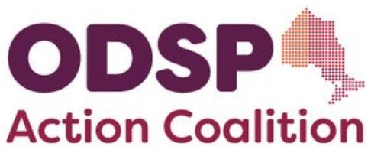

Become a member of the Coalition!

ODSP Action Coalition is a province-wide coalition led by people with disabilities on ODSP, with many allies including community disability agencies, anti-poverty groups & individuals, legal workers, health care professionals, policy experts and other NGOs.. People with disabilities on ODSP should not have to live in poverty. Our mission is to push for improvements to the Ontario Disability Support Program so that folks with disabilities can live with justice and dignity.

To become a member, complete the information requested below and send this form back to us. All information will be kept confidential.

Mail: ODSP Action Coalition, c/o Income Security Advocacy Centre, 1500-55 University Avenue, M6H 2H7
Email: odspactioncoalition@gmail.com

(please print clearly)
- First & Last Name:

1a. City/Town/Region:
- ODSP Recipient/Applicant?: (Y/N)
- If you’re part of, or represent an agency/organization, please tell us which one:

3a. Do you foresee any conflicts of interest re: your organization? (Y/N

- Your preferred email address:

Subscribe to ODSP AC’s General Announcement list? ( Y/N )
(From this list you can expect to receive typically two emails per month containing details to upcoming Coalition meetings, and other news/items of interest to our community. It is not a discussion list and you can unsubscribe at any time. No pressure or obligation).
- Preferred phone number(s):

- Due to the COVID pandemic, all of our meetings are currently being held via Zoom. For a quick tutorial, click here: https://youtu.be/h2XfxVXJqDY
- Every member brings unique skills and experience to the coalition. Are there any particular skills, knowledge and/or experience that you would like to share with the coalition? (If yes, please indicate all that apply with ‘x’):

__ Graphic/ Web Design
__ Writing Correspondence/Taking Meeting Minutes
__ Speaking/Facilitating
Other (please specify):
- We currently have two active committees in which members may get involved, albeit there is considerable overlap between the two. Each committee meets once per month (during regular business hours).

Please pick one or both:
- Policy & Research Committee (PRC) (___)
    - Develops policy papers
    - Conducts policy research
    - Writes submissions to government, etc.
- Public Awareness and Advocacy (PAAC) (___)
a. Organizes with local communities, demonstrations, etc.
b. Conducts workshops
c. Petitions and media

- Anything else you would like to share?
Thank-you for your interest in ODSP ActionCoalition. We are a grassroots volunteer coalition that needs the help and support of advocates like you so that we may continue our mission to push for improvements to ODSP, and defend the rights, inclusion and dignity of people with disabilities everywhere.

We’ll review your information and get back to you in the coming days. Thank you in advance for your patience.

