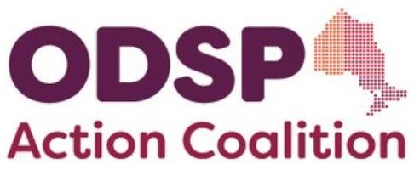

Become a member of the Coalition!

ODSP Action Coalition is a grassroots, volunteer advocacy group led by people with disabilities on ODSP, along with a network of valued allies that includes legal clinic workers, reps from poverty/disability-related NGOs/NPOs, social policy experts, students in a related field of study and those with friends/loved ones on ODSP, among other advocates. All Coalition decisions are primarily led by our ODSP recipient members, who each volunteer from their (our) own homes, using our own meagre resources.
To become a member, complete the information requested below and send this form back to us. All information will be kept confidential.

Mail: ODSP Action Coalition, c/o Income Security Advocacy Centre, 1500-55 University Avenue, M6H 2H7
Email: odspactioncoalition@gmail.com

(please print clearly)
- Preferred First & Last Name:

1a. City/Town/Region:
- ODSP Recipient/Applicant?: (Y/N)
- If you’re part of, or represent an agency/organization, please tell us which one:

3a. Do you foresee any conflicts of interest re: your organization? (Y/N

- Your preferred email address:

Subscribe to ODSP AC’s General Announcement list? ( Y/N )
(From this list you can expect to receive typically two emails per month containing details to upcoming Coalition meetings, and other news/items of interest to our community. It is not a discussion list and you can unsubscribe at any time. No pressure or obligation).
- Preferred phone number (optional):

- All of our meetings are held virtually via Zoom during weekdays. For a quick Zoom tutorial, click here: https://youtu.be/h2XfxVXJqDY
- Every member brings unique skills and experience to the coalition. Are there any particular skills, knowledge and/or experience that you would like to share with the coalition? (If yes, please indicate all that apply with ‘x’):

__ Graphic/ Web Design
__ Writing Correspondence/Taking Meeting Minutes
__ Speaking/Facilitating
Other (please specify):
- We currently have two active committees in which members may get involved, albeit there is considerable overlap between the two. Each committee meets once per month (during regular business hours).

Please pick one or both:
- Policy & Research Committee (PRC) (___)
    - Develops policy papers
    - Conducts policy research
    - Writes submissions to government, etc.
- Public Awareness and Advocacy (PAAC) (___)
a. Organizes with local communities, demonstrations, etc.
b. Conducts workshops
c. Petitions and media

- Anything else you would like to share?
Thank-you for your interest in ODSP ActionCoalition. We are a grassroots volunteer coalition that needs the help and support of advocates like you so that we may continue our mission to push for improvements to ODSP, and defend the rights, inclusion, autonomy and dignity of people living with disabilities.

We’ll review your information and get back to you in the coming days. Thank you in advance for your patience.

